3 DAYS 2 NIGHTS FREE & EASY PENANG PACKAGE
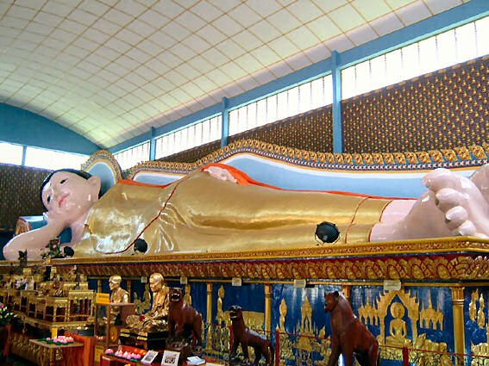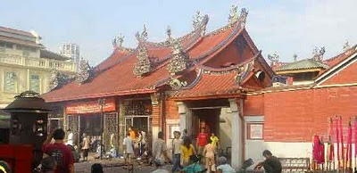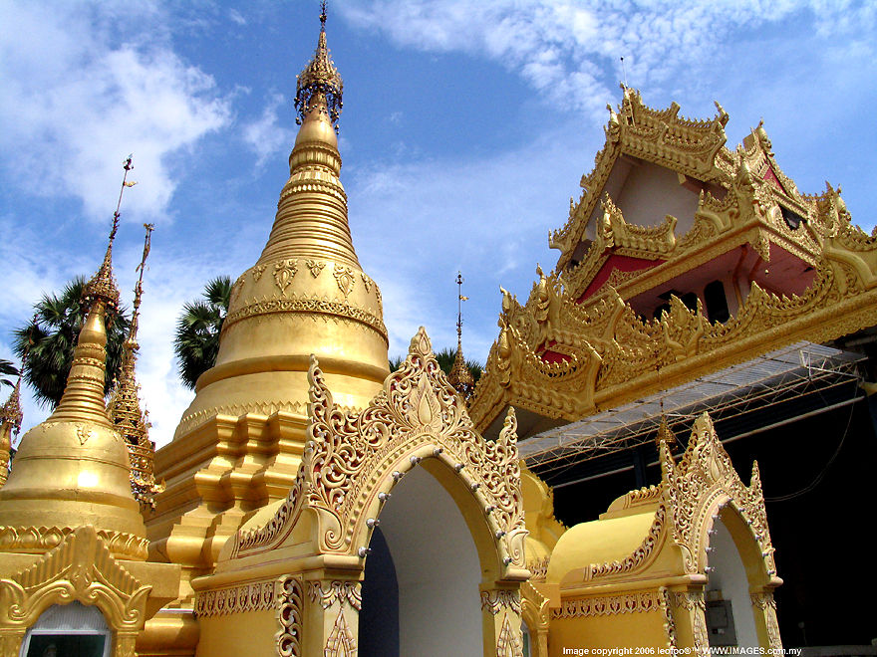

Hotel | Twin / Triple  (per person) | Child with extra bed | Child without bed | Single supplement additional
(3*) Grand Continental Hotel | RM 280.00 | RM 225.00 | RM 170.00 | RM 125.00
(3*+) Berjaya Georgetown Hotel | RM 310.00 | RM 250.00 | RM 190.00 | RM 160.00
(4* ) Copthorne Orchid Hotel | RM 350.00 | RM 280.00 | RM 210.00 | RM 195.00
(4*) Paradise Beach Resort | RM 360.00 | RM 290.00 | RM 220.00 | RM 210.00

IITINERARY :

Day 1 ARRIVE PENANG
Arrive Penang airport , proceed for a half day tour – visit Reclining Buddha, Dharmmikarana Burmese Temple, Penang’s Milionaries Row, The Goddess of Mercy (Kuan Yin) Temple. Check in hotel.

Day 2 PENANG (BREAKFAST)
Breakfast at hotel, free at own leisure

Day 3 PENANG – OUT (BREAKFAST)
Breakfast at hotel, free until transfer to Bus station/Airport for your departure

Package Inclusive :
~ Transfer in/out.
~ 2 Nights accommodation (Twin sharing).
~ 2 Breakfast.
~ Half day tour (seat in coach)

Package EXCLUDED :
~ Personal expenses.
~ Tipping.
~ Travel Insurance.
~ Domestic air ticket
~ Entrance fees for sightseeing.

REMARKS :
~ Rate is based on minimum 02 paxs and above.
~ The Hotel reserve all rights
~ Validity : Until March 2012 .
~ All rate quoted base on RINGGIT MALAYSIA

PEAK SEASON SURCHARGE :-
~ Grand Continental Hotel peak season surcharge @ RM 35.00 per room per night fall on public holiday & school holiday 2012 .
~ Berjaya Georgetown Hotel peak season surcharge @ RM 50.00 per room per night on 23 Dec – 04 Jan 12 ,
06 – 08 Feb & 22 – 26 Jan 2012.
~ Copthorne Orchid hotel peak season surcharge @ RM 50.00 per room per night on 21 Dec – 03 Jan 12 ,
21 Jan – 26 Jan 12 .
~ Paradise Beach Hotel peak season surcharge @ RM 50.00 per room per night on 20 Dec – 05 Jan 12 ,
21 – 27 Jan 12 .

